Busking in Romsey Town Centre

Busking and other forms of street entertainment are welcomed in Romsey.

Good street entertainment can enhance the vitality of the town centre and provide pleasure to visitors and residents. You do not need a licence or permission to busk or provide street entertainment in the Test Valley Borough Council area. However, there are certain restrictions and you are expected to follow a code of practice.

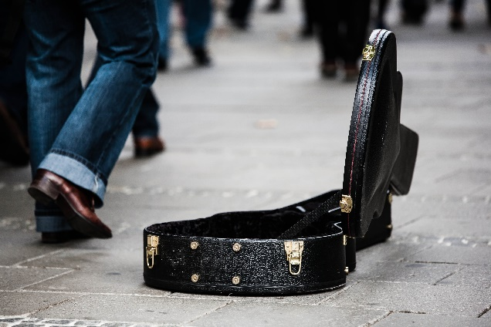

Restrictions

Busking should not interfere with planned events such as markets and should not take place at authorised events, such as Beggars Fair, Food Festival or Christmas lights switch on, unless previously agreed with Romsey Town Centre Manager.

Certain pathways and open space in Romsey Town Centre are privately owned and busking requires the permission of the land owner, this includes by Waitrose store and Latimer Walk (between Waitrose and Latimer Street), Aldi carpark, the grounds of Romsey Abbey and Dukes Mill.

Code of Practice

Buskers and street entertainers must follow the Code of Practice for street entertainment:

- Music or voice shall not be amplified to a level or to be so loud that either can plainly be heard at a distance of 50 metres. Mains or generator-powered amplification is not permitted. Busking must not be intrusive, a nuisance in nearby premises or affect the public or the use of entrances/exits to shops, phone boxes, post boxes, ATMs or to shop window displays

- Private land apart, entertainment is restricted to a maximum of one hour in any one place (pitch) and shall not be repeated in that place or within 50 metres of it within two hours. Note: particularly noisy entertainers, e.g. bagpipers or drummers, should not perform for longer than 30 minutes

- Entertainers shall not obstruct the highway. Entertainers are also responsible for ensuring that the highway is not obstructed by people gathering to listen or to watch the performance (note: Highway includes any footpath, pavement or open pedestrian area or place)

- Entertainers shall not make use of street furniture, such as public seats, lampposts and railings

- Pitches chosen shall satisfy the above criteria and must not be within 50 metres of another busker
- Entertainment is only permitted between the hours of 10.00 hours and 20.00 hours.

- No sign shall be displayed inviting payment (except where a collection for charity has been authorised by Romsey Town Council via a Street Collection Permit)

- You must not actively collect money, but you may have a receptacle e.g. box, hat or musical instrument case into which you can accept donations from members of the public in return for your performance

- You are not able to sell anything such as tapes, CDs and T-shirts while you busk unless you have first obtained a street trading consent from Test Valley Borough Council

- Entertainers shall not perform in a manner which is dangerous to themselves or to the public

- Entertainers shall not dress, act, or say anything which is likely to cause alarm, distress or offence to a member of the public

- Entertainers must stop performing immediately if requested to do so by a Police Officer or Council Officer.

For more information on this code of practice please contact:

Judith Giles  Chief Officer  Romsey Town Hall  1 Market Place  Romsey  SO51 8YZ  Telephone: 01794 512837  Email: chiefofficer@romseytc.org.uk​ | Licensing Section  Legal & Democratic Service  Test Valley Borough Council  Beech Hurst  Weyhill Road  ANDOVER  SP10 3AJ  Telephone 01264 368013  Email licensing@testvalley.gov.uk  www.testvalley.gov.uk/licensing

