In the Chair: Councillor C. Wise
Attendance:

P. Cllr. D. Baverstock P. Cllr. J. Critchley
P. Cllr. J. Burnage A. Cllr. K. Dunleavey
-. Cllr. J. Cairney -. Cllr. M. Southey
P. Cllr. M. Cooper P. Cllr. J. Parker
P. Cllr. I. Culley P. Cllr. C. Wise
P. Cllr. N. Daas A. Cllr. S. Wilkinson

Chief Officer: Judith Giles Present:
Public: 0 Debbie Forder – Events Manager
Howard Brisland – Building Manager
Lisa Mortimer - TCM
Cllr. J. Ray
Cllr. S. Lamb

- APOLOGIES
Apologies received from Cllr. K. Dunleavey and Cllr. S. Wilkinson

- DECLARATION OF INTEREST
None

- MINUTES
The minutes of the Building & Town Committee Meeting held on 15th December 2020 were confirmed as a correct record.
PROPOSED: Cllr. J. Burnage
SECONDED: Cllr. M. Cooper
CARRIED
Matters Arising – None

- PUBLIC PARTICIPATION - None

- ARCHIVIST REPORT – None

- REVIEW OF BOOKINGS
- TOWN HALL
The Events Manager reported the income for 2020-21 is down substantially due to COVID-19. However bookings are on the increase, in particular weddings for 2021-22, COVID19 guidelines permitting.

- REVIEW OF FILMSHOWS
The Events Manager confirmed Filmshows at the Plaza are currently not being shown due to Covid restrictions

- TOWN HALL – COVID 19
The Chief Officer reported due to Lockdown 3 as per COVID-19 Government Guidelines the Town Hall is closed and the staff are working from home.

- FINANCE REPORT
The Chief Officer presented Month 7. It was noted income is down due to COVID-19.

- PROPOSED LIFT INSTALLATION
The Building Manager reported work commenced on the lift installation on 8th February 2021. He gave a brief update of work currently being carried out.

- BUILDING MANAGER’S REPORT (Appendix 1)

- TOWN CENTRE MANAGER ‘S REPORT (Appendix 2)
The Committee thanked the Town Centre Manager for her detailed report.
A discussion was held with regards to the following:-
AEC Protection Report detailing security patrols which took place throughout December 2020 in the town
Drainage issues in Middlebridge Street. Cllr. M. Cooper to email Town Centre Manager with contact details of the Contractor for the flood alleviation scheme and contact for an overview of the whole interactions within the hydrological system.
Cllr. M. Cooper reported temporary closure of The Hundred will continue for the foreseeable closure. New temporary barriers have been designed for The Hundred. It is hope to regularise traffic in Portersbridge Street with additional signage. A consultation is to be carried out by HCC taking into consideration issues for mobility scooters.
Cllr. I. Culley expressed concern regarding independent shops and asked the Town Centre Manager if she was going to liaise with retailers encouraging them to join the virtual high street which will run alongside physical shopping. The town Centre Manager reported she is currently working on this and will update at next Building & Town Committee Meeting.

- EMERGENCY PLANNING GROUP
The Chief Officer reported she has been working closely with Unity to ensure support for the Vaccination Centre at the Crosfield Hall. Cllr. John Parker reported Social Media is proving to be a successful route to get information out to the public. The Chief Officer has Teams Meetings with other authorities/organisations on a regular basis to keep informed of what is happening and what is required.

- LAND AT THE STAR
The Committee agreed to leave the Land at the Star as a Herb Garden with seats and refused the request from the Landlady at the Star Inn to use as a Pub Garden.

- GRANTS
Tree of Life Café
RESOLUTION NO. 21/29
It was RESOLVED to grant £500 to the Tree of Life Café
PROPOSED: Cllr. J. Parker
SECONDED: Cllr. J. Burnage
CARRIED

It was agreed funds left in the 2020-2021 Grants Budget will be transferred into the Grant Budget 2021-22

Meeting closed 8.45p.m.

Building Manager Report to Building and Town Committee 9th February 2021.

1 | Electrical | A new electrical distribution board (BD1) has been fitted. This serves the rear of the building and is now able to service the new lift.
2. | Lighting | LED Background lighting has been installed into the Court Room. Replace the old spotlights. Some other old lighting units have also been changed to LED
3. | Covid Working | I am regularly checking the information updates from both the Government and Health & Safety Executive. The Risk Assessment and guidance is then updated. This is taking an unprecedented amount of time.
4. | Christmas Lights | We have not taken the lights down yet as they are providing a “boost” to morale at this dark time. The tree was removed as planned as this would have looked sparse by now and is also our biggest H&S risk. We checked with our insurers and Hampshire Highways had to extend our permit. They were both very prompt and helpful. They will now start to be removed from 15th February. We cannot leave them up any longer as they impede other works in the Town using “cherrypickers”. Some of this has had to be rescheduled.
5. | Lift | Works will start on 8th February. Building control is still to be finalized. It is focused upon fire safety which we feel we have well covered. We have started discussions with our tenant Cranfield Trust on coordination of works through their offices and their lease.
6. | External Decorations | Still planned to follow on from lift works.
7. | New Bench Seat | I have made contact with Hampshire Highways and I am proceeding through the process. The bench is shown on the next page. It is the same as other RTC benches.

Item No 11
Lisa Mortimer MRICS - Romsey Town Centre Manager
Report to Romsey Town Council Building and Town Committee 9th February 2021

Item No | Subject | Report
1 | General commentary | Since my last report to your 15th December 2020 meeting, the advent of the Kent Covid mutation has seen a roller coaster of Covid Regulations for England. In the Test Valley and Romsey, Tier 3 regulations were in existence prior to Christmas. As cases increased, Tier 4 Regulations came into force on Boxing Day with the third national lockdown brought in on 5th January.  Once again Lockdown 3 meant that all non-essential retail shops were to forced to close as well as personal care such as hairdressers, beauticians and the like. Also indoor markets and market stalls selling non-essential goods also had to cease trading.  These restrictions have once again had an impact on our Town Centre over the last month. However there appear to have been more people around the town during the day compared with previous lockdowns either doing essential shopping or out walking. There also appear to be more social gathering that saw me witness interventions by police on foot patrols on several occasions over the last week, especially in the Market Place. In the first lockdown, there was a sense of desertedness about the town for many weeks and an absence of traffic.  After a series of anti-social incidents, burglaries and acts of vandalism in and around the town centre before Christmas; Hampshire Police introduced a Section 35 dispersal order just before Christmas. This appears to have helped to reduce incidents in the Town Centre, although it is known there have been an increased number of car break ins around Romsey.  Anecdotally traders have reported a mixed trade over a much shortened Christmas trading period. Certainly there was none of the normal pre-Christmas buzz around the town but at least the enhanced Christmas lights and tree helped to offset some of the gloom. However the usual post- Christmas sales in non- essential shops did not take place as Tier 4 restrictions came into force on 26th December. Additional grants will be available for those businesses affected by the pre-Christmas and most recent lockdowns. TVBC are again administering these grants.  Preliminary figures from the Office of National Statistics (ONS) suggests that 29.6% of retails sales took place on line in December 2020. The ONS also reports that in 2020, the amount spent in online retail sales increased by 46.1% when compared with 2019 as a whole, the largest annual increase since 2008.  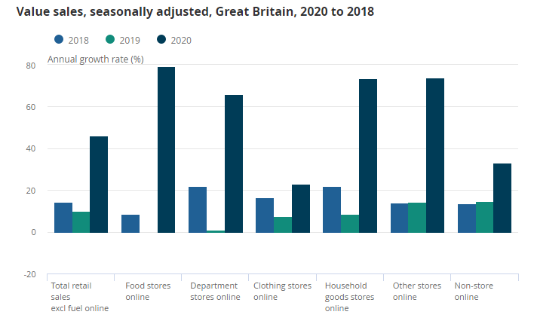  This data reinforces the necessity for local business communities to harness this additional marketing/potential on-line sales channel. A further more detailed item in respect of my work with David Gleave of TVBC to build a new on line platform for local businesses to go online appears later in this report.  The proposed offering follows the models established by some of the following:  Risborough Basket  https://theboroughbasket.co.uk (Basingstoke)  Support local and shop in Winchester City Centre - Visit Winchester  Home :: Hampshire Fare  About Alresford (Retail)  A separate item later in this report contains a report from AEC Protection about their deployment to provide additional security around the town centre over Christmas. From their report, you will see that those stores/shops, which limited the number of people entering their premises and had personnel at their entrance doors, saw that shop lifting was substantially reduced. Their report highlights premises which had suffered from shop lifting together with recommendations as to how the incidence of shop lifting could be reduced.  On the crime front, Bradbeers was the subject of a burglary early on Monday 18th January. I was advised that security devices installed within the store and the prompt response of the police limited the amount of perfume that was stolen from the window displays only.  The current restrictions will no doubt have a continuing impact on our Town Centre businesses, including our events programme, at least for the first half of 2021. At the current time, we have been holding in abeyance taking any town centre event bookings until things become clearer.
2 | Around the Town Centre: | The large beech tree that was located in the garden at the rear of the TSB Bank’s garden – 6 Market Place was felled over Christmas under emergency tree works permission because its roots were found to be severely infected with honey fungus making it unstable.  I have been in contact with the Managing Director of Brightbeech Developments Ltd, who have considerable property interests in Romsey. He reports that like many commercial landlords, their tenants are experiencing considerable business difficulties if they are in the hospitality and retail sectors with rent holidays and abeyances being sought. Work on their developments to the rear of 10 Market Place and the former Abbey Hotel to include the relocation of Kitchenhaus from 10 Market Place to the former Abbey Hotel.  TVBC announced that it was suspending car parking charges in its car parks with effect from 6th January. With only essential shops open, this has not had too significant an impact although it is noted the Royal Mail vans are utilising a lot of the spaces in the Lortemore car park at the rear of Abbey Walk. In should be noted that many other local authorities have not suspended their parking charges as the loss of income will not be made up by central government grants.  Refurbishment of the TVBC owned houses in Portersbridge St commenced in the middle of January. The 7 houses - Nos 1-13 Portersbridge Street had been leased to Aster Housing. Due the cost of repairs and as they are only 2 bedroomed, Aster decided to hand them back to TVBC. TVBC are refurbishing them to add to their stock of open market rental housing held by its wholly owned subsidiary Valley Housing. Refurbishment works are due to completed in April with the properties being available to rent shortly thereafter.  Refurbishment works are also under way on 30 Alma Road, which TVBC has recently acquired to add to its Valley Housing privately rented housing company.  The non statutory highway diversions, whereby there is supposed to be no through traffic using Portersbridge Street from the Hundred diversion doesn’t appear to be that effective. Perhaps the wording on the signs are ambiguous and not that well formulated in that they appear as  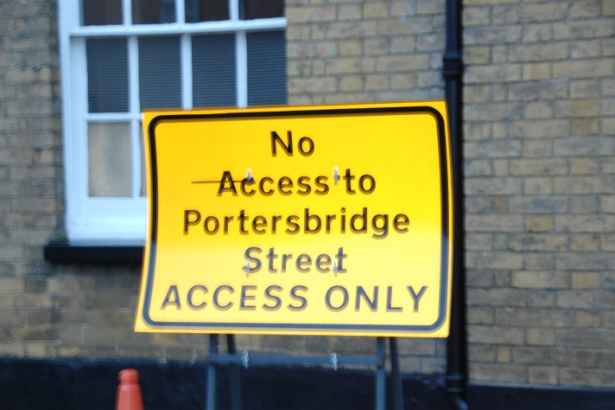  “Perhaps “Portersbridge Street No through traffic ACESS ONLY” might have been better.  The third phase of the Romsey Flood alleviation works in Middlebridge Street is nearing completion. The works compound on Broadwater Road that has been used in conjunction with many recent highways schemes in the town centre, as shown below, has had to be compressed in its extent.  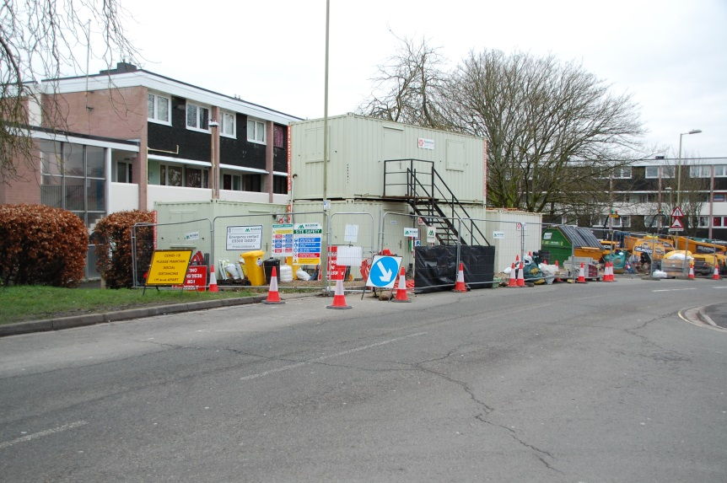  Although the verge area between the highway and the flats had been previously used as part of site compound, a tree officer decided that this time such an activity could have an adverse impact on the trees despite the contractor having put down protective materials. It was proposed that even though the contract has only a few weeks to run, it was to be relocated to the Newton Lane car park at considerable cost. Fortunately common sense has prevailed and with some compression of the compound, it will not now be moved, although barriers, machinery and traffic cones down Middlebridge Street has created a “chicane” along its length.  Although I have lived off Middlebridge Street for quite a few years now and was there in the winter of 2013/2014, I cannot recall the street actually flooding. Other residents who have lived in the locality can’t recall it flooding significantly. The current works on Middlebridge St comprise the creation of new surface water gullies and outfall pipes into the Holbrook Stream that runs down the entire length of Middlebridge St. Hopefully the new sluices that have been installed off Greatbridge Road will prevent any excessive amounts of water coming through the town and into the Holbrook Stream as the new outfall pipes from the gullies in Middlebridge St are set well below the pavement level and are not fitted with non return flaps as shown below:  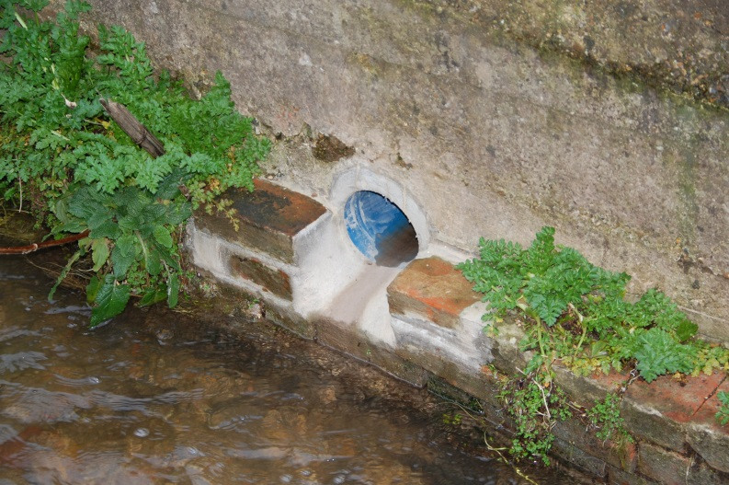  If the Holbrook stream did fill up with flood water, the water could come up through the gullies and flood the road. With the increased number of gullies draining straight into the stream, it is presumed that a risk assessment had been undertaken to consider what would happen if there was a pollution incident with a pollutant spillage on the Middlebridge St carriageway that went into the new gullies and then drained straight into the Holbrook stream, which in turn discharges into the main River Test.  It is hoped that after all of the Romsey Flood alleviation infrastructure, that has been installed, will be maintained to ensure their future effectiveness. The lack of maintenance is already apparent from the photo below, whereby one of the newly constructed gullies from the highway to the newly created drainage ditches at Mainstone is choked  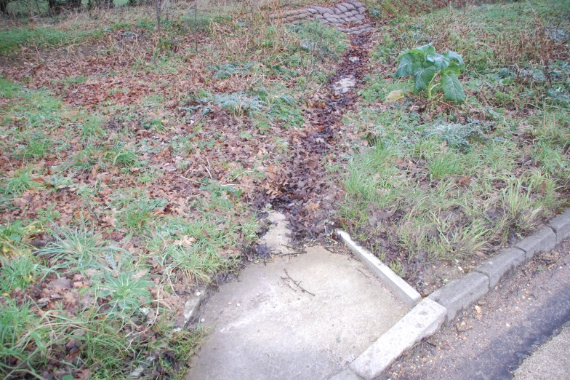  All too often roadside infrastructure is installed and then heavy machinery with flail roadside trimmers drive along and over gullies/channels such as this. In this particular example, it would have been hoped that the Highway Authority would have cleared out the accumulated debris in a newly constructed gully such as this before the winter season with its attendant rainfall.
3 | Town Centre events and markets: | The Sunday Romsey Maker’s Market in the Piazza and The Cornmarket have been suspended due to the Covid regulations that only permits essential retailing. The Tuesday, Friday and Saturday Charter Markets are still operating for essential retailing only.  In my December report, I had advised that it had become apparent that the Makers Market and other events that take place on highway land in the Town Centre have not been properly regularised.  In 2020, a User Protocol was prepared in conjunction with Romsey Future and now appears on the Town Council’s web site:  MARKET PLACE - ROMSEY TOWN COUNCIL (romseytc.org.uk)  The above user protocol was not taken to a formal conclusion in that there are some areas which require clarification, more especially in respect of potential liabilities and responsibilities in that we all know that in these litigious times, the absence of any legal/formal agreements can have unforeseen consequences.  I would recommend that the following actions should be taken:  - An agreement is formulated and entered into with Hampshire County Council as Highway Authority and the Romsey Town Council that would formalise matters in respect of the following:  - Charter Market stall holders and other Market operators such as the Makers Market to operate on Highway land on the central Piazza/Market Place under the management and control of Bradbeers and the Town Council as some Charter Market stall holders currently use the Piazza on Charter Market days when the Charter Market Agreement with Broadlands, Bradbeers and the Town Council only applies to the Cornmarket area.  - Other stallholders and market operators who have been approved as being suitable to trade by the Town Council (in accordance with the Romsey Future User Protocol) to operate in the Cornmarket and other highway areas within the Town Centre to include the Piazza, subject to any requisite Highway Closure Orders being obtained by the lead operator/organiser. The organiser/operator of any events will be responsible for submitting a proposed event plan with an appropriate risk assessment together with proof that they have in place the requisite insurances. An oganiser /operator would be responsible for obtaining any Street Trading Licences. The Town Council would be responsible for booking and managing these types of events. Events in this category could include the Beggars Fair, Food Festival, Antiques Fairs, and Makers Market.  - In these times of financial pressures on local authorities, a potential tariff of charges could be prepared to cover the Town Council’s costs for administering and managing commercial bookings for events on Highway land and consideration be given to charges being levied.  - That the Town Council via its insurance broker seeks confirmation from its existing insurers that the above proposals would be covered by its existing insurance policies.
4 | Planning and redevelopment matters: | The Abbey Hotel – conversion of the front ground floor into retail space is proceeding under permitted development. Application for a variation to the original residential planning permission now sought. Application No: 20/03180/VARS vary condition 07 of 20/00701/FULLS (Demolition of toilet blocks to rear and conversion, alterations and extension to provide four dwellings comprising a two-storey two-bedroom house, a three-bedroom maisonette, a two-bedroom and a one bedroom flat; provision of external staircase) to replace drawings 7983/P31, 7983/P32A, 7983/P27, 7983/P26, 7983/P29, 7983/P28, 7983/P02A with drawings 7983/P31A, 7983/P32B, 7983/P27B, 7983/P26C, 7983/P29B, 7983/P28B, 7983/P02B. Not yet determined  14 Market Place (former Santander) – the Covid regulations and their effect on the hospitality industry mean that alterations/refurbishment works to convert the ground into a cocktail dining venue to be called the Exchange have slowed/been held in abeyance.  8, Market Place – application for micro pub, internal alterations and new signage approved by TVBC on 15th December. Alteration works appear to have commenced.  7, Market Place – No significant work has been observed or is noticeable externally in this unit for its opening by Upload Printing for retail printing and embroidery  21a, Market Place Charters Estate Agents have now opened and are fully operational  1& 2 Stirling Walk (Application No: 20/03211/FULLS) Use of existing first floor restaurant floorspace (A3) above existing Natraj Indian restaurant as an independent restaurant (A3). Yet to be determined  Iron Art The Forge 6 Portersbridge Street (Application No: 21/ 00285/FULLS) Demolition of workshop (Use Class B1) and erection of dwelling (Use Class C3), parking and associated works. Not yet determined.
5 | Vacant units: | 34 The Hundred – former Carphone Warehouse unit still being marketed. Available by an assignment of an existing lease which is due to expire in June 2021. Rent passing £20,000 pa  37, The Hundred – former Grade II Red Lion building that had been occupied by Charters Estate Agents and is owned by Brightbeech is now vacant and available to rent. 149.7 sq m/1611 sq ft of space on 2 floors available. Asking rent £25,000 per annum on a full repairing and insuring lease  4 Eastwood Court , Broadwater Road - 2,104 Sq ft/195.5 Sq m’s on ground, first and second floors 9 allocated car parking spaces Asking Rent: £31,560 per annum,  32 Bell St – Second floor office suite 98.3 sq m’s/1058 sq ft. Asking rent £20,000 inclusive of utilities and service charges.  14 The Hundred (Clarks) – posted to let on 27/12/2020 by Primmer Olds Total Net Internal Area 1,473 sq ft 136.85 sq m’s ground floor shop and store room. Available on a new full repairing and insuring lease Asking Rent £50,000 per annum.
6 | Temporary closure of the Hundred & other highway matters | On 21st December the following e-mail was received from Karen Brisley of HCC Highways by a number of Town Councillors and staff  From: Brisley, Karen <Karen.Brisley@hants.gov.uk>  Sent: 21 December 2020 02:32  To: J Burnage <cllrjburnage@romseytc.org.uk>; cooper22tt@aol.com <cooper22tt@aol.com>; TCM <tcm@romseytc.org.uk>; Chief Officer <chiefofficer@romseytc.org.uk>  Cc: Churchill, Leon <leon.churchill@hants.gov.uk>; Styszynski, Jakub <Jakub.Styszynski@hants.gov.uk>; Breen, Brandon <Brandon.Breen@hants.gov.uk>  Subject: RE: The Hundred  Dear All,  Thank you for including me in this email chain, as it highlights a really important issue.  Unfortunately we can’t have anyone other than a traffic management qualified operative moving the traffic management on the public highway, as this is a criminal offence.  This applies to delivery drivers and local councillors. Please could this message be communicated to the Councillors and the businesses along The Hundred.  After the 23rd December I am out of the office until 4th January. If there are any issues with the barriers over this period please report this to Leon Churchill during working hours (email address above or 07879 458728) or if out of hours call the Police on 101 and this will then filter through to Skanska.  Councillor John Parker replied on behalf of the Town Council. Since that time, the Highway Authority has replaced the plastic barriers with more substantial metal barriers as shown below:  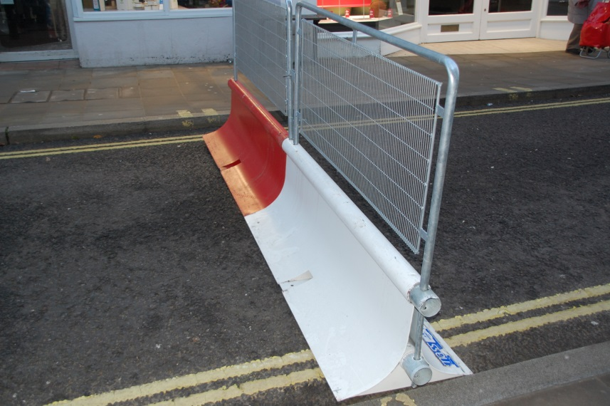  Initially , the barriers at the Latimer Street end of the Hundred closure had been left open  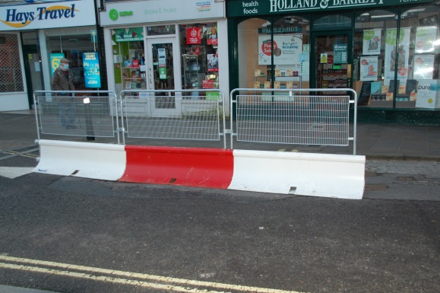  Prior to the introduction of the metal barriers and their complete closure, delivery lorries for the Co-op would move the plastic barriers back and reverse up the Hundred to unload outside the store.  Now they have to use smaller lories and unload in the bay outside the Phoenix on Latimer St, which may not be vacant at their time of calling. Delivery trollies and cages cause more of an obstruction along the pavement outside the Phoenix and in the very wet weather of recent deliveries get very wet.  I have been unable to readily find anything on the HCC Highways web site in respect of the temporary road closures.  Does the Town Council need to raise this with HCC and our lead authority TVBC?  As I walk about the Town Centre, I report pavement and road issues to HCC through their reporting portal. Two most recent issues reported
 |  | 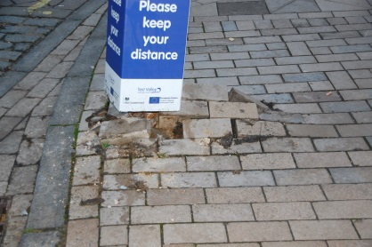  Raised paviors outside Boots after bollard knocked over by a vehicle | 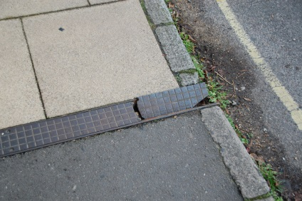  Broken gutter channel cover outside No 11 Middlebridge St
 |  | HCC Highways do not appear to respond very fast by actions to reported items
7 | Report from Ace Security | Attached is the report from Ace Security in respect of their provision of a Christmas security presence
8 | Romsey Futures | The next Romsey Future Combined Meeting is scheduled for Monday 8th February
9 | Potential on line trading platform for Romsey Busineses | As previously advised, I have been in further discussions with David Gleave of TVBC in respect of devising ways in which local residents and businesses can be made aware of local retail and business offerings. Specialist consultancy advice has been obtained and funded by TVBC. I am due to discuss the matter further on Thursday 4th February. I will therefore provide a verbal update to your meeting on developments.
10 | The Cranfield Trust lease | Currently The Cranfield Trust occupy office space on the 1st and Ground Floor of the Town Hall under a lease dated 6th February 2020. From and including 20 December 2019 to 19 December 2022. As a result of the building works connected with the lift installation, the tenant’s demise will be re-configured. As a result The Cranfield Trust have considered their space requirements going forward and although they wish to remain at the Town Hall, they are proposing to surrender their Ground Floor space and occupy just the first floor office accommodation. As their occupation of the offices will be disrupted whilst the lift installation works are in progress, it has been proposed that an appropriate rent holiday is granted and negotiations are in progress for a new rent for the reduced demise. This will be documented via a new legal agreement.
11 | My way of working | The extract below is taken from the Romsey News and Information Facebook page on 2nd February in connection with a question that was posed  “Why has a piece of plywood been screwed across the front of the horse trough in the Corn Market? It looks as though someone is trying to hide the name of Cowper-Temple, but why.  More to the point, in order to do so, they have actually driven. Screws though the ancient stone work. Can any body explain what is happening here.”  In the ensuing conversation, Mark Edgerley was asked about the situation.  The following are abstracts from the Facebook conversation that ensued  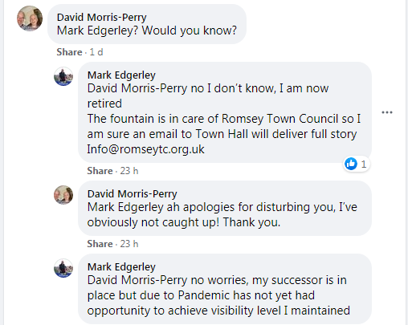  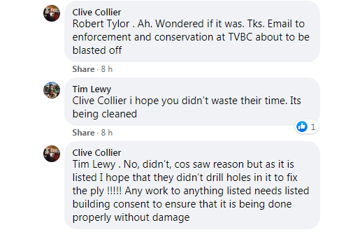  Councilor Parker intervened to provide an explanation in this particular matter. This small episode illustrates how social media can completely dominate an individuals or organisation’s time to respond to postings. I have made a conscious decision not to respond to any postings on Romsey News and Information on Facebook, leaving it to Councillor John Parker to keep an eye on things in his role as one of the administrators and moderators.  In respect of my actual profile in the community, Covid has meant that a physical public profile around the town would not have been that productive with many businesses being closed or just trying to survive. I have chosen to take a more targeted and proactive role by meeting and conversing with key business personnel and seeking to enhance their offerings through things like the on line platform. In addition, it has taken quite a bit of time in my first few months to ascertain what, if any agreements were in place for street based events and activities.  .  As far as I am concerned there will be plenty of time in the future for enhanced public profiling when it is safe to do so. My ethos has always been that we were born with two ears and one mouth and that is the proportion I work to by listening and responding accordingly not just for the sake of saying something. As far as I am concerned the role of Town Centre Manager requires a considerable amount of listening and trying to tread an impartial path to represent the Town Council in its quest to enhance the Romsey Town Centre experience for both local residents, visitors and the business community.

LM 02.02.2021

ATTACHMENT 2

TCM Meetings since last report in December 2020

1st December 2020 – Online Meeting Digital High Streets - TVBC

2nd December 2020 – Vaccination Support - Unity

9th December 2020 – Local Shopping Platforms - TVBC

14th December 2020 – Romsey Future Combined Meeting - TVBC

6th January 2021 – Covid Vaccination Catch Up Meeting – Unity/RTC

7th January 2021 – Cranfield Trust – Lease Meeting – RTC/Cranfield Trust

18th January 2021 – Test Valley CSMG Teams Meeting

28th January 2021 – Market Meeting - RTC

1st February 2021 – Romsey Disabled Partnership Meeting (Zoom)

Planned Meetings

4th February 2021 – Local Digital Shopping Platform – TVBC/Andover BID/ LM

8th February 2021 – Romsey Future Combined Meeting - TVBC

